LA SALLE UNIVERSITY

COLLEGE OF COMPUTER STUDIES

Software Requirements Specifications
for
CodeTest A Role Playing Game

Espadera, Wilfred
Solas, Justine Joy
Vapor, Renz Ryan

Signature

Justine Joy Solas Renz Ryan Vapor
Budget Officer, Researcher and Writer, System Analyst and
Game Programmer Game Programmer

Wilfred Espadera
Team Leader, System Analyst,
Game Programmer

Change History
Date | Reason for changes | Version
2/14/2018 | Use Cases Scenario  Product Functions  User Characteristics  Hardware and Software Interfaces | 1.0.1
2/22/2018 | Product Functions  User Interfaces  User Characteristics | 1.0.2
2/28/2018 | Product Functions  Software Interfaces | 1.0.3

Preface
The Following Software Requirements Specification (SRS) describes the proposed plan to be taken by the students of the College of Computer Studies of La Salle University-Ozamiz. As such, it deals only with the delivery of the software component of the project and has dependencies on the Hardware portion of the products since it will be distributed to desktops of computer labs of the said school except for those computer that are running MacOS.

Table of Contents
Signature 2
Change History 3
Preface 4
Table of Contents 5
List of Figures 6
List of Tables 7
1. Introduction 9
1.1. Purpose 9
1.2. Scope 9
1.3. Definitions, Acronyms and Abbreviations 10
1.4. References 11
1.5. Overview 12
2. Overall Description 14
2.1. Product perspective 14
2.2. Product functions 16
2.3. User characteristics 21
2.4. Constraints 21
2.5. Assumptions and dependencies 22
3. Specific Requirements 23
3.1. External interface requirements 23
3.2. Functional requirements 28
3.2.1. Use case 1 28
3.3. Performance Requirements 40
3.4. Design constraints 41
3.5. Software system attributes 41
3.6. Other requirements 42
4. Appendixes 43
5. Index 4
4

List of Figures
Figure # Figure Name Page #
2.1.1 Conceptual Paradigm 15
3.1.1 Game Main Menu Interface 24
3.1.2 Select C Topic and Character 25
3.1.3 Pause Game 26
3.1.4 Options 27
3.2.1 Use Case Diagram 28

List of Tables
Table # Table Name Page #
1.3 Definitions, Abbreviations and Acronyms 11
3.2.1.1 Play Game 30
3.2.1.2 Options 31
3.2.1.3 Exit Game 32
3.2.1.4 Choose Character 33
3.2.1.5 Select C Topic 34
3.2.1.6 Pause Game 35
3.2.1.7 Continue Game 36
3.2.1.8 Quit to Main Menu 37
3.2.1.9 Change Graphics 38
3.2.1.10 Adjust Volume 39
3.2.1.11 Change Resolution 40

Introduction
This section gives a scope description and overview of everything included in this SRS document. Also, the purpose for this document is described and a list of abbreviations and definitions is provided.

Purpose
The purpose of this document is to give a detailed description of the requirements for the “CodeTest RPG” software. This document will illustrate the complete declaration and purpose for the development of the system. This document will explain all system constraints, interface and interactions with other external applications. This document is intended to be proposed to the client for approval and will serve as a reference for in developing the system for the development team.

Scope
The “CodeTest RPG” is an offline role playing game which allows CCS Students of La Salle University to test their skills and knowledge in the C programming language. The system should be free to accessed by students through computers installed with the system.
The “Code Test RPG” SRS will mainly cover the software requirements in developing the system, this includes the programming languages to be used in coding the software, the different software programs that will be used in designing and developing the system, capabilities of the system, and the requirements of the system in order for it to run.
The students are only required to launch the game which will be installed on the computer. The system is also capable of letting the students to select specific language topics that will be covered during the game.

Definitions, Acronyms and Abbreviations
Term | Definition
2D | stands for two-dimensional. It has two dimensions: height and width. Seen as a level picture.
Activity Diagram | is basically a flowchart to represent the flow from one activity to another activity. The activity can be described as an operation of the system.
Architectural Design | characterizes the connection between major basic components of the product, the structural styles and configuration designs that can be utilized to accomplish the prerequisites characterized for the framework, and the requirements that influence the path in which engineering can be actualized.
Class Diagram | is a type of static structure diagram that describes the structure of a system by showing the system's classes, their attributes, operations (or methods), and the relationships among objects.
Edutainment Games | are games explicitly designed with educational purposes, and at the same time to provide entertainment.
Component Level Design | changes basic components of the product engineering into a procedural portrayal of programming segments. Data acquired from the class-based models, stream models, and behavioral models fill in as the reason for segment outline.
NPC | stands for Non-Playable Character, is any character that is not controlled by the player.
Programming | is an activity or procedure of composing PC programs.
Programming Language | is a formal language that indicates an arrangement of guidelines that can be utilized to deliver different sorts of output
RPG | stands for Role Playing Game, is a game in which players assume the roles of characters in a fictional setting.
Sequence Diagram | is a graph that shows a progression of collaborations between protest cases after some time. Regularly used to show the handling portrayed being used case situations.
Single Player | is usually a game that can only be played by a single person
Software Quality Assurance | is a process that guarantees that created programming meets and agrees to characterized or institutionalized quality details.
Use Case Diagram | is a rundown of activities or occasion steps, normally characterizing the connections between a part (known in the Unified Modeling Language as an actor) and a framework, to accomplish an objective.
User | is a person who uses or operates something, especially computers or software.
[Table 1.3] Definitions, Acronyms and Abbreviations

References
2D Game Creation:
https://unity3d.com/learn/tutorials/topics/2d-game-creation
And document of NAMMPSoft Inc. 11.1.2007, access to document is through the link: https://cs.gmu.edu/~dfleck/classes/cs421/spring08/SampleProject/FINAL%20SRS.pdf
Character collision and physics:
https://docs.unity3d.com/ScriptReference/CharacterController.OnControllerColliderHit.html
https://docs.unity3d.com/ScriptReference/Physics.html
Interface and Essentials:
https://unity3d.com/learn/tutorials/topics/interface-essentials
Resources for this document has been used from the author Matthew Buckley-Golder in his website: https://drive.google.com/file/d/0B1rAoATbeK4zRl8wanp2Um1qaGc/view
Scripting:
https://unity3d.com/learn/tutorials/s/scripting
Sprite Designing:
https://docs.unity3d.com/Manual/SpriteEditor.html
Tutorials:
https://unity3d.com/es/learn/tutorials
World Creation:
https://github.com/cyclejs-community/roguelike/blob/master/package.json

Overview
The remainder of this document includes three chapters and appendixes. The second one provides an overview of the system functionality and system interaction with other systems.
This chapter also introduces different types of stakeholders and their interaction with the system. Further, the chapter also mentions the system constraints and assumptions about the product.
The third chapter provides the requirements specification in detailed terms and a description of the different system interfaces. Different specification techniques are used in order to specify the requirements more precisely for different audiences.
The fourth chapter deals with the prioritization of the requirements. It includes a motivation for the chosen prioritization methods and discusses why other alternatives were not chosen.
The Appendixes in the end of the document include the all results of the requirement prioritization and a release plan based on them.

Overall Description
This section will give an overview of the whole system. The system will be explained in its context to show how the system interacts with other systems and introduce the basic functionality of it. It will also describe what type of stakeholders that will use the system and what functionality is available for each type. At last, the constraints and assumptions for the system will be presented.

Product perspective
The system will be an offline game; this game will allow the user to play on a RPG (Role Playing Game) type of game with only one user. The game’s main goal is to let the user learn different topics of the C programming language while playing. The CodeTest - A Role Playing Game will allow the user to choose the desired C programming language topic displayed in the menu screen, explore the world of the game and battle NPC’s and win either by completing the code or answering the questions the NPC has given. . The offline game will have a compiler for the sole purpose of the game’s main objective, to complete the code each time the user enters combat. The compiler will check if the users have inputted a certain code that is being ask by the NPC (Non-Playable Character) when it’s played by the user.

System Interfaces
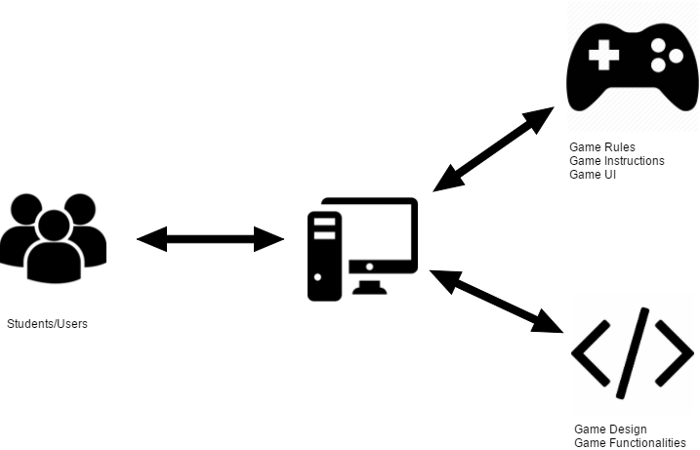
[Figure 2.1.1] Conceptual Paradigm
As shown in the figure above, the students/users are able to access the game offline which is installed in that particular PC. Students/Users loads the game using a unit where the game is installed. The system loads the game design and functions for the game to work properly. System then displays the game’s UI which describes what the system or game looks. After the user loads New Game, system send rules and instructions for the player to understand what is the game and how to play the game
User Interfaces
The user interface will be of ease to the players of the game. The developers of the game would like the U.I to be simple, as what Pokemon games do to their UI. As the player starts the game, they are taught the basic and fundamental actions/movements when playing the game through conversing the player’s mom or the NPC’s around the said town. The menus of the game will be designed solely to the respondent’s desire for the UI to look good in their eyes and ease of use. Only the specified modules for the menu will be applied in the game.
Hardware Interfaces
Once inside the game, the player interacts using their keyboard and mouse. The purpose of the keyboard is for the players to navigate the area of a region or exploring the region itself. It is also for the players to be able to fill out the missing code when the combat phase has started. Player’s mouse is for interacting the user interface itself, whethe he/she wants to play the game, change options of the game and quitting the game to be directed to the desktop
Software Interfaces
The game should be capable of running on most Windows operating system as long it has met the game’s specific requirements and enough to run a game made using Unity game engine. Windows 7, 8.1 and 10 are mostly the supported operating systems that can handle Unity made games.

Product functions
The game will have the options New Game, Options and Exit Game in the main menu interface. The New Game button will allow the user to create a new game, prompting the user to select 1 C topic the wished out of the 8 options before loading the game. Options button lets the user change the in-games options. And lastly, the Exit Game button, of course, will allow the user to quit the game. They will be directed to users desktop. And inside the game, users can freely explore the in-game world. In terms of battle system, it will be much like Pokemon. But this time, in order for them to beat the NPC, they will have to code by following what the NPC has said. Of course, the users have the freedom to avoid battles from NPC’s.
Hints Management - This function allows the player to search for hints gathered from defeating NPC’s after a battle. Hints works like from the popular game Wordscape in which when the user uses a hint, it reveals a fragment of the line of the code. Player does not always get the hints after defeating an NPC. It is only limited to some to avoid abuse of using hints.
Function features:
- The system should allow the player to collect multiple hints from battling NPC’s
- The system should allow the player to use multiple hints acquired from previous battles to complete a line of code in a current battle.
- The system should allow to reveal a part of a line of code from using hint(s)
Combat Management - This function allows the players to engage in combat with an NPC if he/she is found or forcibly entered the combat with an NPC. In order to get through the NPC, the player must complete the challenge. Whether it is a test about the selected C topic or complete the code, player must win in order to get through, and might even win a hint.
Function features:
- The system should allow the player to enter the combat if player is found within range of the NPC’s vision or if the player talked to the aggressive and forcibly entered combat phase
- The system should allow the player to edit and complete the missing lines of code in order to progress
- The system should allow the player to not only complete the code but to answer a one-item test case and will still have a chance to get a hint.
Choose Character - A function that allows the player to select between the two character to be used in the game. The characters that can be selected are a male and a female character. Choosing either one of them does not have a great impact on the storyline of the game, as they both are the protagonist of the game and has the same ending
Function features:
- The system should allow the player to select his/her desired character from the two selections, whether the player wants to play a male or a female character
Choose C Topic - This function allows the player to select “one” topic out of 8 topics from a dropdown list. The topics that are in the dropdown lists are based from the survey results acquired by the proponents from the students of Bachelor of Science in Information Technology and Bachelor of Science in Computer Science. It covers the Programming 2 topics in which the students find it most difficult for them. Choosing the topic will affect the game, as it will be the test and coding cases as you make your way to the game.
Function features:
- The system should allow the player to select only ONE topic out of 8.
- The system should load the selected C topic test cases and complete-the-code cases
Play Game - This function manages in creating a new game, which the player is able to play the game by select a topic and a character before proceeding to the game. It must also allow the player in pausing and resuming the game anytime. These functions also allow the player to quit or save the played game.
Function features:
- The system should create a new game when the player chooses to play the game
- The system must allow the player to select one topic and a character in order to play the game
- The system must allow the player to quit the game and to the main menu
- The system should allow the player to pause and resume the game
Options - This functions manages the background music of the game, graphics of the game and the screen resolution when playing the game. It also allows the player to change the three differently
Function features:
- The system should allow the player to set the volume of the game’s background music
- The system should allow the player to set the in-game’s graphics
- The system should allow the player to set the screen resolution of the game
Exit Game- This functions manages the termination of the current game. It allows the player to quit the game or quitting to main menu
Function features:
- The system should allow the player to quit the game and be directed to the desktop
- The system should allow the player to quit to the game’s Main Menu when in-game
Continue Game - This function of the Play Game manages the resuming of the game, especially if the player has paused the game. The player can always call to press “Escape” or click “Resume Game” button to unpause the game.
Quit Game / Quit to Main Menu - This function of the Play Game serves to terminate the current game and leads the user to the main menu of the game. The player will have to pause the game and click “Quit to Main Menu or Main Menu” and it’ll lead him/her to the main menu of the game.
Change Graphics - This function of the Options serves to change the current graphic resolution of the game to adjust to the user’s performance. It could either be Low for low-end units, Medium for the “it-can-run games that are released in the said year” or High for units that can run all of the games released within that said year.
Adjust Volume - This function of the Options serves to adjust the background music volume of the game. It is also called the Master Volume because it controls all the audio’s volume levels. Players get to adjust the volume’s slider from right to left. Max right means full volume while on the other hand means mute.
Change Resolution - This function of the Options serves to change the screen resolution of the game’s window. Players can only select one resolution. If fullscreen is selected, the remaining 3 will be inactive and can’t be clicked unless un-checked by the player, and otherwise if one of the 3 numbered resolution is clicked, it also disables the fullscreen.

User characteristics
The game is intended for the Bachelor of Science in Information Technology and Bachelor of Science in Computer Science students. Students that find Programming 2 too difficult for them to understand from simply listening to their adviser of the said subject and activities. Most of the students have access to computers of the said school’s laboratories. Because students nowadays uses gaming as a medium of learning, the proponents took the chance out of it. Students of the said courses are looking for a way to learn and at the same time, to learn from a simple video game. Since the game’s purpose is intended to help them understand the difficult topics of Programming 2 especially C, the game focuses on providing tests and code-to-proceed cases. In the near future, CodeTest - A Role Playing Game will be installed specifically to the computers of the said laboratory whom the said subject will take place.
The user can play the game select the desired c topic and choose a character to be used while playing the game. If there’s any adjustments to the game’s settings the user can adjust the settings in the option button. The player of this game are the students who have difficulties in understanding C programming.

2.4. Constraints
- The game will be developed using C#
- Designing of the game will be done using Unity.
- The coding platform for developing the game will be the engine’s built-in compiler
- Possible bug or glitch in game while user is coding
- Possible bugs or glitches while user is playing the game
- Budget must be met
- Project deadline must be met

Assumptions and dependencies
Since the application is a web based application, there is a need for the internet browser.
- It is assumed that the users will have decent computer units.
- After completing the game, they have improved their skill from the topic the user chose
- The game will be accessible all the time.
- Users have already installed the Unity Player plugin in their respective units
- No sudden teleportation of player to any areas of the game
- No bugs or glitches that occur when in combat system of the game
- Collision and Physics in-game should work all the time
- A user can only select a single C topic out of 8 options
- Animations and movements should also work except if the game’s paused
- Should run on operating systems that are 7 and up

Specific Requirements
This section contains all of the functional and quality requirements of the system. It gives a detailed description of the system and all its features.

External interface requirements
This section provides a detailed description of all inputs into and outputs from the system. It also gives a description of the hardware, software and communication interfaces and provides basic prototypes of the user interface.
3.1.1 User interfaces
Either a first time user of the game or not, the users will only be prompt to click the “Play G ame”. After clicking the button, a screen will appear that prompts the user to select one out of all 9 buttons in which the consequences of clicking the chosen C topic replacing the whole questions and tests in the in game to be the selected C topic in which the user chose.
After choosing the desire C topic, character selection screen loads. Player either choose a male or female character to be played throughout the span of the story of the game and its M.O(Main Objective) of the game. Prologue scene loads

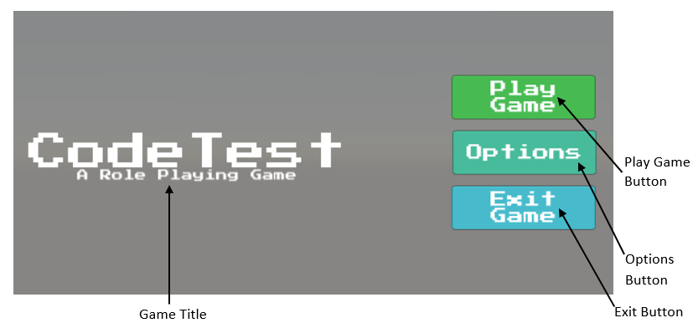
Figure 3.1.1 Game Main Menu Interface
The figure above shows the user interface system of the game which inlcudes Play Game, Options and Exit Game. Play Game has sub menu in which the player must select a C Topic and a character to be used before playing the actual game. Options has also sub menu buttons for the players to reduce the game’s resolution, graphics and volume.

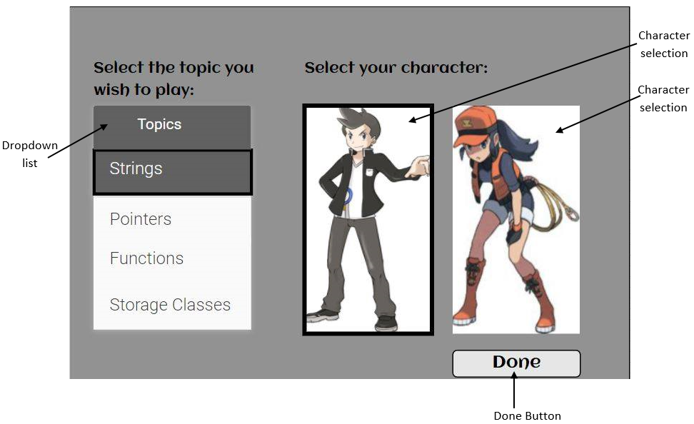
Figure 3.1.2 Select C Topic and Character
After clicking the “Play Game” button located in the Main Menu of the game, the figure above shows a dropdown menu of topics to be choose and a male or female character in which only one can be selected for the player to use the chosen character in game.

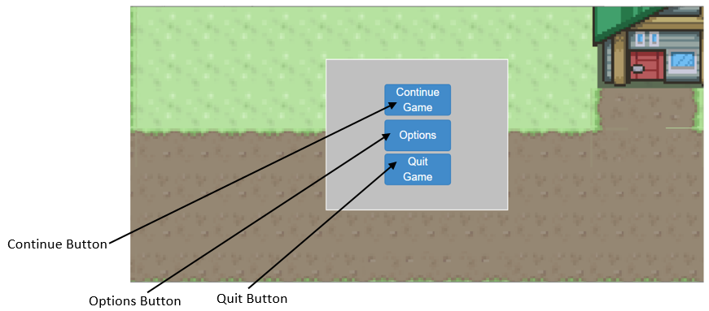
Figure 3.1.3 Pause Game
When the player pauses the game, the figure above shows the buttons that will be displayed when pausing. Quitting the game redirects the user to the main menu of the game

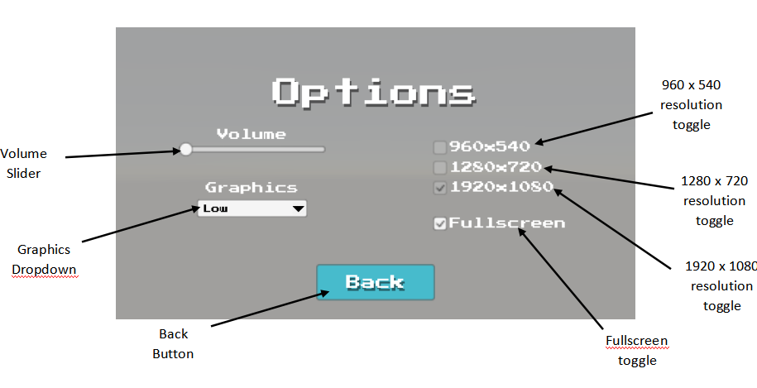
Figure 3.1.4 Options
Clicking the Options button will result to displaying the three buttons that will be responsible for running the game smoothly or depending the user’s choice of adjustments.

3.1.2 Hardware Interfaces
None
3.1.3 Software Interfaces
The software interfaces used are:
Game Engine:
- Unity
Character Creation:
- Adobe Photoshop
- Piskel
Game Level Designs:
- Tiled
- Tiled2Unity
Audio:
- Adobe Premier
- Adobe Audition

Functional requirements
One of the most important thing to be considered in making SRS (Software Requirement Specifications) is to make a Use Case diagram
Use Cases
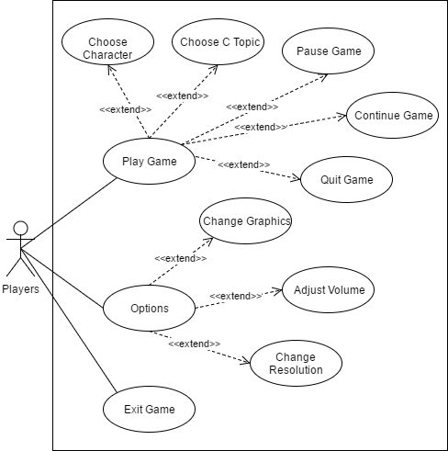
Figure 4: Use Case Diagram

Player Use Case List
UC1 Play Game: Allows the player to play the game
UC2 Options: Allows the player to configure the audio, video and resolution settings of the game
UC3 Exit Game: The game will terminate
UC4 Choose Character: Allows the player to select character, either Male or Female
UC5 Choose C Topic: Allows the player to choose one topic out from 9 topics of C.
UC6 Pause Game: The game will temporary stop in action or pause the game.
UC7 Continue Game: The game will resume
UC8 Quit Game: The game terminates and will return to the main menu.
UC9 Change Graphics: Allows the player to adjust the game’s graphics
UC10 Adjust Volume: Allows the player to adjust the game’s volume
UC11 Change Resolution: Allows the player to adjust the window’s resolution of the game.

3.2.1 Functional Requirements 1.1
Use case name: Play Game | UniqueID: U1
Area: Player’s Play Game
Actor(s): Student
Description: The user clicks the “Play Game” button and should be able to proceed to selecting a topic and a character
Triggering Event: Clicking the Play Game button
Steps Performed (Main Path)
- Player launches the game
- Player clicks the Play Game
- Player is directed to the next scene
Preconditions: Player is on Main Menu
Postconditions: Select C Topic and Character
Requirements met: Allow the player to play the game
Priority: Medium
Risk: High
[Table 3.2.1.1] Play Game

3.2.1 Functional Requirements 1.2
Use case name: Options | UniqueID: U2
Area: Game Settings
Actor(s): Student
Description: The user clicks the “Option” button and game displays different options for the user to adjust
Triggering Event: Clicking the Options button
Steps Performed (Main Path)
1. Player launches the game
2. Player clicks the Options
3. User adjusts settings
Preconditions: Player is on Main Menu
Postconditions: Graphics, Audio or Screen Resolution is changed
Requirements met: Allow the player to adjust the settings
Priority: Medium
Risk: High
[Table 3.2.1.2] Options Game

3.2.1 Functional Requirements 1.3
Use case name: Exit Game | UniqueID: U3
Area: Main Menu
Actor(s): Student
Description: The user clicks the “Exit Game” button and should be able to terminate the game and be directed to the user’s desktop
Triggering Event: Clicking the Exit Game button
Steps Performed (Main Path)
1. Player launches the game
2. Player clicks the Exit Game button
3. Player is redirected to the desktop
Preconditions: Player is on Main Menu
Postconditions: Player is on desktop
Requirements met: Allow the player to quit the game
Priority: Medium
Risk: High
[Table 3.2.1.3] Exit Game

3.2.1 Functional Requirements 1.4
Use case name: Choose Character | UniqueID: U4
Area: Play Game
Actor(s): Student
Description: The user should be able to choose a character to be used in the game
Triggering Event: Clicking the Play Game button
Steps Performed (Main Path)
1. Player launches the game
2. Player clicks the Play Game button
3. Player is directed to the Character Selection screen
4. Player selects a character
Preconditions: Player is on Main Menu
Postconditions: Player is on Character Selection screen, and is able to select a character
Requirements met: Allow the player to select a character
Priority: High
Risk: High
[Table 3.2.1.4] Choose Character

3.2.1 Functional Requirements 1.5
Use case name: Select C Topic | UniqueID: U5
Area: Play Game
Actor(s): Student
Description: The user should be able to select a topic out of the 8 and use the selected topic as the mean for coding out the NPC’s way after entering combat.
Triggering Event: Clicking the Play Game button
Steps Performed (Main Path)
1. Player launches the game
2. Player clicks the Play Game button
3. Player is directed to the Character Selection screen
4. Player selects a character
5. Player selects a topic from the dropdown list
Preconditions: Player is on Main Menu
Postconditions: Player is on Character Selection screen, and is able to select a character and a topic out from the 8
Requirements met: Allow the player to select a character and a topic
Priority: High
Risk: High
[Table 3.2.1.5] Select C Topic

3.2.1 Functional Requirements 1.6
Use case name: Pause Game | UniqueID: U6
Area: Gameplay
Actor(s): Student
Description: The user presses “Esc” button and game pauses temporarily
Triggering Event: Clicking the Esc button
Steps Performed (Main Path)
1. Player launches the game
2. Player clicks the Play Game button
3. Player is directed to the Character Selection screen
4. Player selects a character and a topic
5. Player is in the game
6. Player pauses the game by pressing “Esc”
Preconditions: Player is in the game
Postconditions: Player is on the Pause Game screen
Requirements met: Allow the player to pause the game
Priority: Low
Risk: Low
[Table 3.2.1.6] Pause Game

3.2.1 Functional Requirements 1.7
Use case name: Continue Game | UniqueID: U7
Area: Gameplay
Actor(s): Student
Description: The user presses “Continue Game” and the game continues after temporarily stopped
Triggering Event: Clicking the Continue Game button
Steps Performed (Main Path)
1. Player pauses the game by pressing “Esc”
2. Player resumes the game by pressing “Continue Game” button
Preconditions: Player is in the Pause Game screen
Postconditions: Player is on the game
Requirements met: Allow the player to continue the game
Priority: Low
Risk: Low
[Table 3.2.1.7] Continue Game

3.2.1 Functional Requirements 1.8
Use case name: Quit to Main Menu | UniqueID: U8
Area: Gameplay
Actor(s): Student
Description: The user clicks the “Main Menu” button and should be able to quit the game and will be redirected to the main menu
Triggering Event: Clicking the Quit Game
Steps Performed (Main Path)
1. Player pauses the game
2. Player quits by clicking “Main Menu” button
Preconditions: Player is in Pause Menu
Postconditions: Player is redirected to the main menu of the game
Requirements met: Allow the player to quit and redirected to the Main Menu
Priority: Low
Risk: Low
[Table 3.2.1.8] Quit to Main Menu

3.2.1 Functional Requirements 1.9
Use case name: Change Graphics | UniqueID: U9
Area: Gameplay
Actor(s): Student
Description: The user is able to change the in-game’s graphics properties to adjust or maximize the performance of the game
Triggering Event: Clicking the Options button
Steps Performed (Main Path)
1. Player presses “Esc” button
2. Player clicks “Options” button
3. Player clicks Change Graphics button
4. Adjusts graphics depending on performance
Preconditions: Player is in-game
Postconditions: Graphics adjusted
Requirements met: Allow the player to change graphics
Priority: Medium
Risk: High
[Table 3.2.1.9] Change Graphics

3.2.1 Functional Requirements 1.10
Use case name: Adjust Volume | UniqueID: U10
Area: Gameplay
Actor(s): Student
Description: The user is able to adjust the in-game’s volume properties, to adjust the sound effects or the background music when playing
Triggering Event: Clicking the Options button
Steps Performed (Main Path)
1. Player presses “Esc” button
2. Player clicks “Options” button
3. Player clicks Adjust Volume button
4. Adjusts volume to user’s bidding
Preconditions: Player is in-game
Postconditions: Volume adjusted
Requirements met: Allow the player to adjust the volume
Priority: Medium
Risk: Medium
[Table 3.2.1.10] Adjust Volume

3.2.1 Functional Requirements 1.11
Use case name: Change Resolution | UniqueID: U11
Area: Gameplay
Actor(s): Student
Description: The user is able to change the in-game’s resolution to adjust the window’s current resolution into either fullscreen, 1920x1080 and etc.
Triggering Event: Clicking the Options button
Steps Performed (Main Path)
1. Player presses “Esc” button
2. Player clicks “Options” button
3. Player clicks Adjust Volume button
4. Adjusts resolution to Fullscreen, 1920x1080 and others
Preconditions: Player is in-game
Postconditions: Resolution adjusted
Requirements met: Allow the player to change the game’s resolution
Priority: Medium
Risk: Medium
[Table 3.2.1.11] Change Resolution

Performance Requirements
Loading the game depends on the processor and if the player’s unit has its own videocard powerful enough to run most games that are newly released, it shouldn’t be a problem running a Unity-made game. As the game uses lots of processing power to load every assets. Characters, maps, the actual interpreter and many others will be loaded, making the game an actual game. In case of game crashing, the game does not support saving the game as it’s purpose is to help the players achieve the goal of every topic they chose, completing the short-lived story game.

3.4. Design constraints
The characters and the NPC’s of the game must match to the game’s short storyline. The assets that will be used for designing the level maps are borrowed from online sources but the developers made their own designs for the actual level maps. The proponents uses C# as their main language for prototyping, designing and testing phases. For the said level maps, Tiled and Tiled2Unity will be the platform in making the said maps. All the stated cannot exist if there isn’t a game engine that will be used, so Unity 3D will be the game engine for developing the game

3.5. Software system attributes
The software system attributes are the following:
• Availability – The game must be available to use at all times, where the user can access and play the game as long as it is installed in his/her particular unit
• Maintainability – The modules of the game must be properly coded. It is also a good practice to document the codes, therefore documenting the source code of the game. The game must be also capable of modifications, even if it’s minor or major. The said game may be used as an adaptation to a bigger project, or improving the game to prevent future bugs and glitches. That’s why updates is a must
• Reliability – Game crashing should not happen in the midst of playing, it might disappoint the players and not play the game again.
• Portability – The game must be capable of running on Windows 7 and up that supports Unity games. Units with processors and video cards enough to run most of today’s popular games can also run the said game
• User Friendly – The design of the user interface will be kept simple. Ease of navigation of user interfaces is also the goal of this game. Menus, buttons and dropdowns will be organized properly in order to avoid confusion to players.

3.6. Other requirements
N/A

Appendixes

Index

